A.     MSBuild verbose logs from Visual Studio IDE :

•         Go to Tools->Options->Projects and Solutions->Build and Run

•         Set “MSBuild project build output verbosity” and “MSBuild project build output verbosity” to Diagnostic

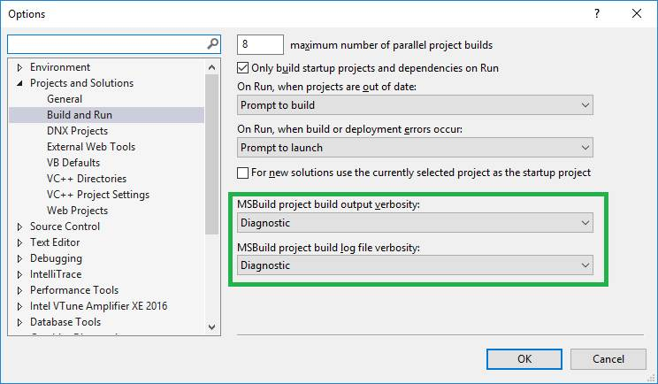

•         Rebuild the solution and send me the build output file.

1. Procmon logs

1.     Download Process Monitor from: <http://www.microsoft.com/technet/sysinternals/ProcessesAndThreads/processmonitor.mspx>

2.     Extract the above folder and run Procmon.exe

3.     Check all the three boxes for File, Registry and Process and Thread activity.

4.     Now Click Filter->Filter. A new dialog box will appear.

5.     Select the name of the process(devenv.exe) and click the button Add :

6.     Now  press Capture button

7.     In Procmon go to File -> Save and select 'All Events' and 'Native Process Monitor Format (PML)' and click OK.